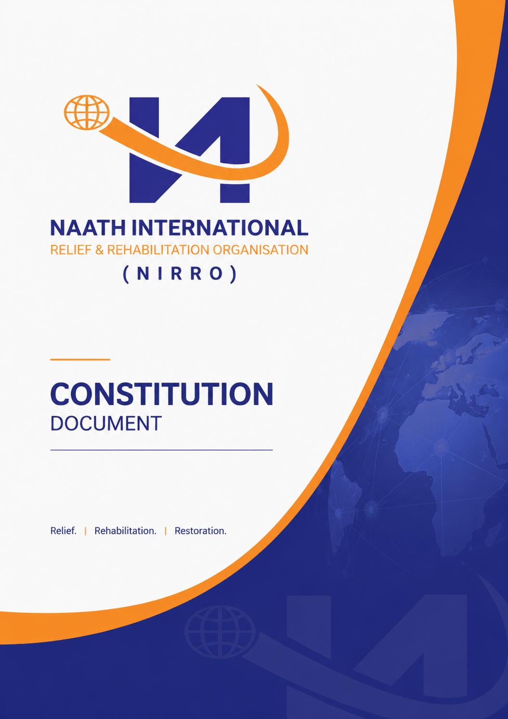

- Naath International Relief & Rehabilitation Organisation(NIRRO)
- Section 1: Preliminary

  - 1.1 Name
The name of the incorporated association is “NAATH INTERNATIONAL RELIEF AND REHABILITATION ORGANISATION INCORPORATED”.
Note: Under section 23 of the Act, the association’s name and registration number must appear on all its business documents.
- 1.2 Purposes
The purpose of the organisation is to deliver relief and rehabilitation support to the Naath Community in Australia and South Sudan, and to support individuals facing hardship in Australia and those displaced in Nuerland.
- 1.3 Financial Year
The Association's financial year is each 12-month period ending on June 30.
- 1.4 Definitions
Key terms used in these Rules are defined for clarity, including Committee, general meeting, associate member, special resolution, the Act, and the Registrar.
(For full definitions, see Appendix A at the end of this document).

- Section 2: Powers of the Association

  - 2.1 Powers
The Association has the power to do all things necessary to achieve its purposes, including but not limited to acquiring property, operating accounts, investing funds, raising and borrowing money, and entering contracts.
- 2.2 Use of Income and Assets
The Association may only use its income and assets to pursue its stated purposes.
- 2.3 Not-for-Profit Status
The Association must not distribute surplus, income, or assets to its members, except for reimbursements or payments for goods/services provided in good faith on standard terms.

- Section 3: Membership, Disciplinary Procedures, and Grievances

  - 3.1 Membership

    - 3.1.1 Minimum Number
The Association must have at least five members.
- 3.1.2 Eligibility
Any person who supports the purposes of the Association is eligible for membership.
Individuals with pending criminal background wouldn’t be allowed to be members as well as individuals with record of violence against the public.
- 3.1.3 Application Process
Applicants must submit a signed, written application to a committee member and may pay a joining fee.
The management committee will review the application and communicate with the applicant in writing eg email or a letter sent to their residence.
- 3.1.4 Consideration of Application
The Committee decides on applications and notifies applicants accordingly.
- 3.1.5 New Membership
Membership commences upon committee approval and payment of the joining fee.
- 3.1.6 Annual Subscription
Annual subscription and joining fees are set at the annual general meeting.
Funds generated from registration fees, donations, and charities wouldn’t be used for illegal means such as political campaigns, civil wars, funding conflicts, or rebellion movements. Funds will only be used for food items or relief meant to support vulnerable people in South Sudan or Australia.
NIRRO is not affiliated with or connected to any political party. Funds will be directed to the affected Nuer areas after thorough consultation is done.
- 3.1.7 Rights of Members
Members entitled to vote have the right to attend meetings, vote, access documents, and propose business.
- 3.1.8 Associate Members
Associate members (e.g., those under 15 years or other classes decided by special resolution) cannot vote but may have other rights.
- 3.1.9 Transfer and Cessation
Membership rights are not transferable and end upon resignation, expulsion, or death.
- 3.1.10 Register of Members
The Secretary maintains a register of members, accessible to members under certain conditions.
- 3.2 Disciplinary Action

  - 3.2.1 Grounds
The Association may discipline members for breaches of rules, lack of support for the Association, or conduct prejudicial to the Association.
- 3.2.2 Disciplinary Subcommittee
A subcommittee hears disciplinary matters.
- 3.2.3 Notice and Hearing
The member is notified and given the opportunity to be heard.
- 3.2.4 Decisions
The subcommittee may reprimand, suspend, or expel a member. There is a right of appeal to an appeal subcommittee.
- 3.3 Grievance Procedure

  - 3.3.1 Application
Grievance procedures apply to disputes between members, the committee, or the association.
- 3.3.2 Mediation
Disputes unresolved between the parties are referred to mediation.
- 3.3.3 Further Action
If mediation fails, parties may seek legal resolution.

- Section 4: General Meetings

  - 4.1 Annual General Meetings
Held within five months after each financial year’s end and includes confirmation of minutes, reports, financial statements, committee elections, and fee determinations.
- 4.2 Special General Meetings
May be convened by the committee or requested by 10% of members.
- 4.3 Notice and Proxies
Notice requirements and proxy voting procedures are specified.
- 4.4 Technology
Meetings may be held using technology allowing simultaneous communication.
- 4.5 Quorum and Voting
Quorum is 10% of voting members; decisions are made by majority, with special procedures for tie votes and special resolutions.
- 4.6 Minutes
Minutes of meetings are to be kept, including attendance, business, decisions, and financial statements.

- Section 5: Committee

  - 5.1 Powers and Role
The Committee manages the Association’s business and may delegate powers except those reserved by law or these Rules.
- 5.2 Composition
President, Vice-President, Secretary, Treasurer, and ordinary members as determined.
- 5.3 Duties
Committee members must act with care, diligence, good faith, and for proper purposes.
- 5.4 Conflict of Interest
Conflicts must be declared and managed, with a conflict of interest register maintained.
- 5.5 Meetings
The Committee meets at least four times yearly, with procedures for notice, urgency, quorum, voting, and minutes.
- 5.6 Election and Tenure
Rules for nominations, elections, ballots, vacancies, and tenure are specified.
- Board of Management:
- The board of management will comprise four members. These members will convene every 6 months to evaluate the progress of the organization and advise on the overall running of the organization. The board will advise the CEO or the director on matters related to the advancement or lack of progress in some areas of the organization.

- Section 6: Financial Matters

  - 6.1 Source and Management of Funds
  - 6.1.1 Only financial members would be allowed to vote and participate in the organization.
Funds may be derived from fees, donations, grants, etc., and must be managed through a financial institution account.
- 6.2 Financial Records and Statements
Proper records are to be kept for seven years, and financial statements are prepared, certified, and lodged as per the Act.

- Section 7: General Matters

  - 7.1 Common Seal
The Association may have a common seal, kept by the Secretary.
- 7.2 Registered Address
The registered address is as determined by the Committee or, by default, the Secretary’s postal address.
- 7.3 Notices
Notices may be delivered in person, by post, or electronically.
- 7.4 Custody and Inspection of Records
Members may inspect certain records, except where confidentiality or the Association’s interests require restriction.
- 7.5 Winding Up
Upon dissolution, surplus assets are distributed to a similar, non-profit body as decided by special resolution.
- 7.6 Alteration of Rules
Rules may only be altered by special resolution and as approved by the Registrar.

- Appendices

  - Appendix A: Key Definitions
(Definitions as per Section 1.4 above)

